Borehole No. GM78
Location Yaw Bibi Akura, Afram Plains
Latitude N 06°57.503’
Longitude W000°31.886’
Date started 31/01/2000
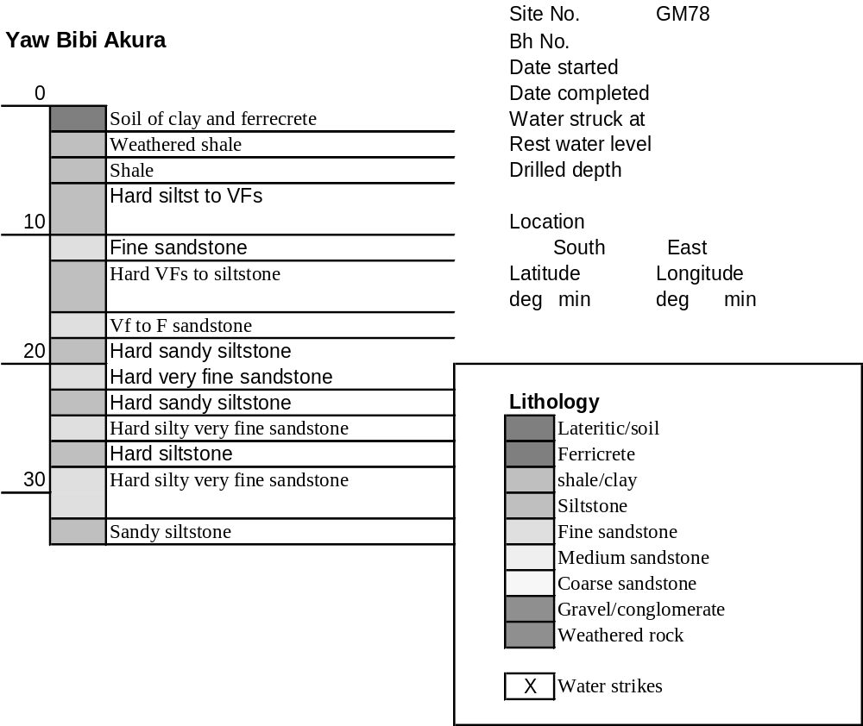Date completed 01/02/2000

Summary Lithological Log
Depth(m)
From To
0 1 Soil of clay and ferrecrete
1 4.1 Weathered mudstone
4.1 7.1 Mudstone
7.1 11.2 Hard siltstone to very fine sandstone
11.2 12.2 Fine sandstone
12.2 15.2 Hard downward fining very fine sandstone to muddy siltstone
15.2 17.3 Hard downward finng silty very fine sandstone to muddy siltstone
17.3 18.3 Very fine to fine sandstone
18.3 20.3 Hard sand siltstone
20.3 22.4 Hard very fine sandstone
22.4 25.4 Hard sandy siltstone
25.4 27.4 Hard silty very fine sandstone
27.4 28.5 Hard siltstone
28.5 33.5 Hard silty very fine sandstone
33.5 34.5 Sandy siltstone

Detailed Lithological Log
Depth(m) Lithology
From To

Soil of silcretised ferrecrete
0 1 Light brown/orange and grey silcretised ferricrete nodules with dark
brown and black Fe and Mn oxide cores

Weathered mudstone
1 2 Light ochre brown to light olive grey weathered mudstones with
orange partings
3 3 Ochre brown and darker olive grey weathered mudstones, some black
MnO along bedding planes
3 4.1 Olive grey weathered but fairly hard mudstones, black MnO along
bedding planes

Mudstone
4.1 5.1 Dark greenish grey and olive green to dark grey mudstones, slightly
weathered with black MnO stains along bedding planes
5.1 6.1 Dark grey mudstones with orange/brown and black staining along
bedding surfaces
6.1 7.1 Dark grey mudstones with orange/brown and black staining along
bedding surfaces

Hard siltstone to very fine sandstone
7.1 8.1 Dark grey very hard siltstone to very fine sandstone, odd thin calcite
vein
8.1 9.1 Dark grey siltstones to very fine sandstones, hard with some mica
9.1 10.2 Hard dark grey compact siltstone to very fine grained sandstone
10.2 11.2 Dark grey hard siltstone to very fine grained sandstone; subordinate
light grey fine grained sandstone with orange brown staining along
joint surfaces

Fine sandstone
11.2 12.2 Dark grey to light grey fine grained sandstone with orange/brown
weathered surfaces

Hard downward fining very fine sandstone to muddy siltstone
12.2 13.2 Hard dark grey very fine grained sandstone
13.2 14.2 Hard dark grey sandy siltstone
14.2 15.2 Dark grey muddy siltstone

Hard downward finng silty very fine sandstone to muddy siltstone
15.2 16.3 Hard dark grey silty very fine grained sandstone
16.3 17.3 Dark grey thinly laminated muddy siltstones

Very fine to fine sandstone
17.3 18.3 Dark grey very fine to fine grained hard sandstone

Hard sand siltstone
18.3 19.3 Hard dark grey well laminated sandy siltstone
19.3 20.3 Hard dark grey well laminated sandy siltstone

Hard very fine sandstone
20.3 21.3 Hard dark grey very fine grained sandstone
21.3 22.4 Hard dark grey very fine grained sandstone, with thin calcite vein

Hard sandy siltstone
22.4 23.4 Hard platy fragments of dark grey muddy siltstone to sandy siltstone
with odd fragment of lighter grey very fine sandstone with weathered
orange brown surfaces
23.4 24.4 Hard dark grey sandy siltstone
24.4 25.4 Hard dark grey sandy siltstone with thin calcite and iron pyrite filled
vein

Hard silty very fine sandstone
25.4 26.4 Hard dark grey very fine grained sandstone (very large fragment)
26.4 27.4 Hard dark grey silty very fine grained sandstone with iron pyrite
inclusion

Hard siltstone
27.4 28.5 Hard dark grey siltstone

Hard silty very fine sandstone
28.5 29.5 Hard dark grey silty very fine grained sandstones
29.5 30.5 Hard dark grey silty very fine grained sandstone with thin brown
sandstone? vein
30.5 31.5 Hard dark grey silty fine grained sandstone
31.5 32.5 Hard dark grey very fine grained sandstone with thin brown sandstone?
vein
32.5 33.5 Hard dark grey silty very fine grained sandstone, platy fragments

Sandy siltstone
33.5 34.5 Hard dark grey sandy silt
Borehole to be continued to 45m on 01/02/00

